OUTPUT
Tasks
- Calculate total & average for each student
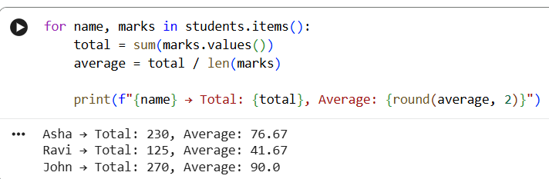
- Identify top scorer
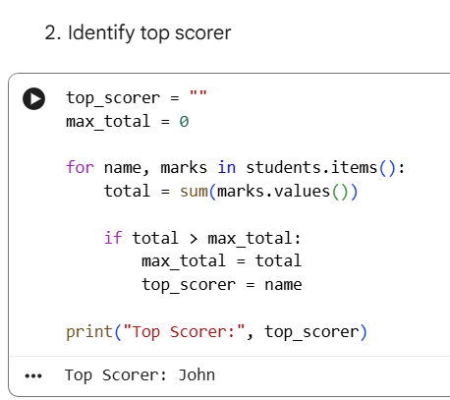
- Find students who failed in any subject
